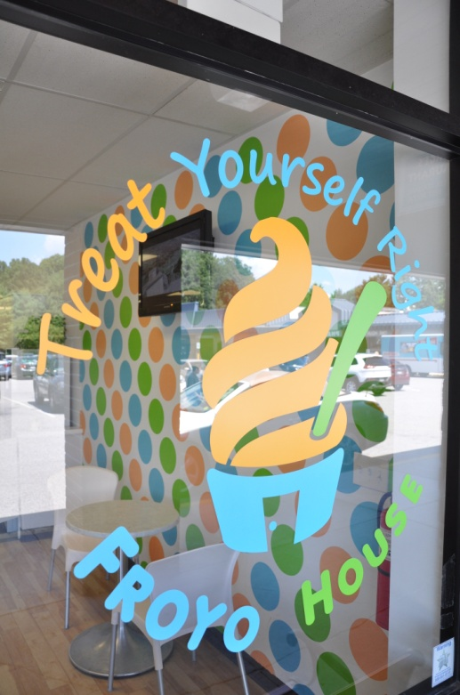
Owning Your Own Froyo House
How Much Does It Cost?
What Are The Fees?
Can I Finance The Cost?
How Long Does It Take To Open? Do I Choose Location?

Costs
- Total cost should range between $300K and $350K. We have opened a store for $285K using a very clean starting space.
  - $150K for machines, furniture, fixtures, and related costs
  - $150K for store construction (build-out)
  - $30K franchise fee
  - Minus an average of $20-30k for Tenant Improvement. (Money given by the landlord to help with construction costs.)

Fees
- One-time $30K franchise fee (the same or lower than industry competitors)
- Unique flat-fee Royalty of $1K per month (substantially lower than all competitors’ percentage based Royalty Fees)
- No other fee’s (others charge marketing, training, etc.)

Financing
- Typical Small Business Administration commercial loans require:
  - Good credit
  - $100K in liquid assets
  - $450K net worth
- Other options are also out there; including utilizing home equity lines of credit and some types of IRA’s to start a business using pre-tax dollars

Timing/Locations
- A store can be opened in as little as 4 months once financing is secured and a location is chosen
- We will assist with choosing a location, and can recommend all the assistance you may need, but the actual store location decision will be up to you

